Investigate the expert…

How it Works!

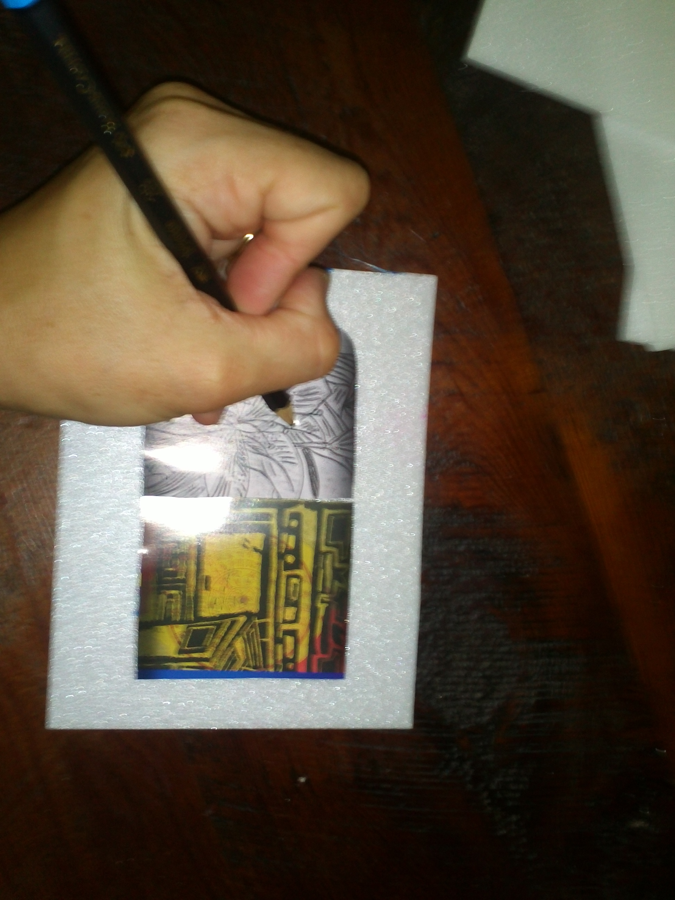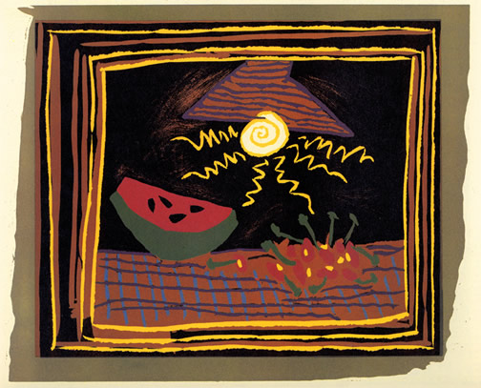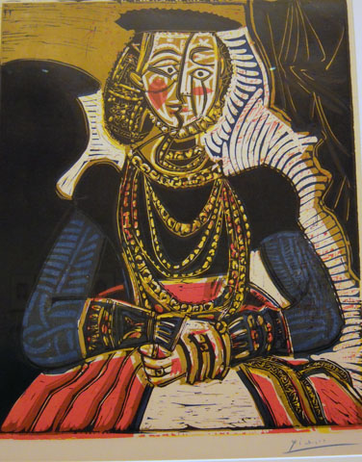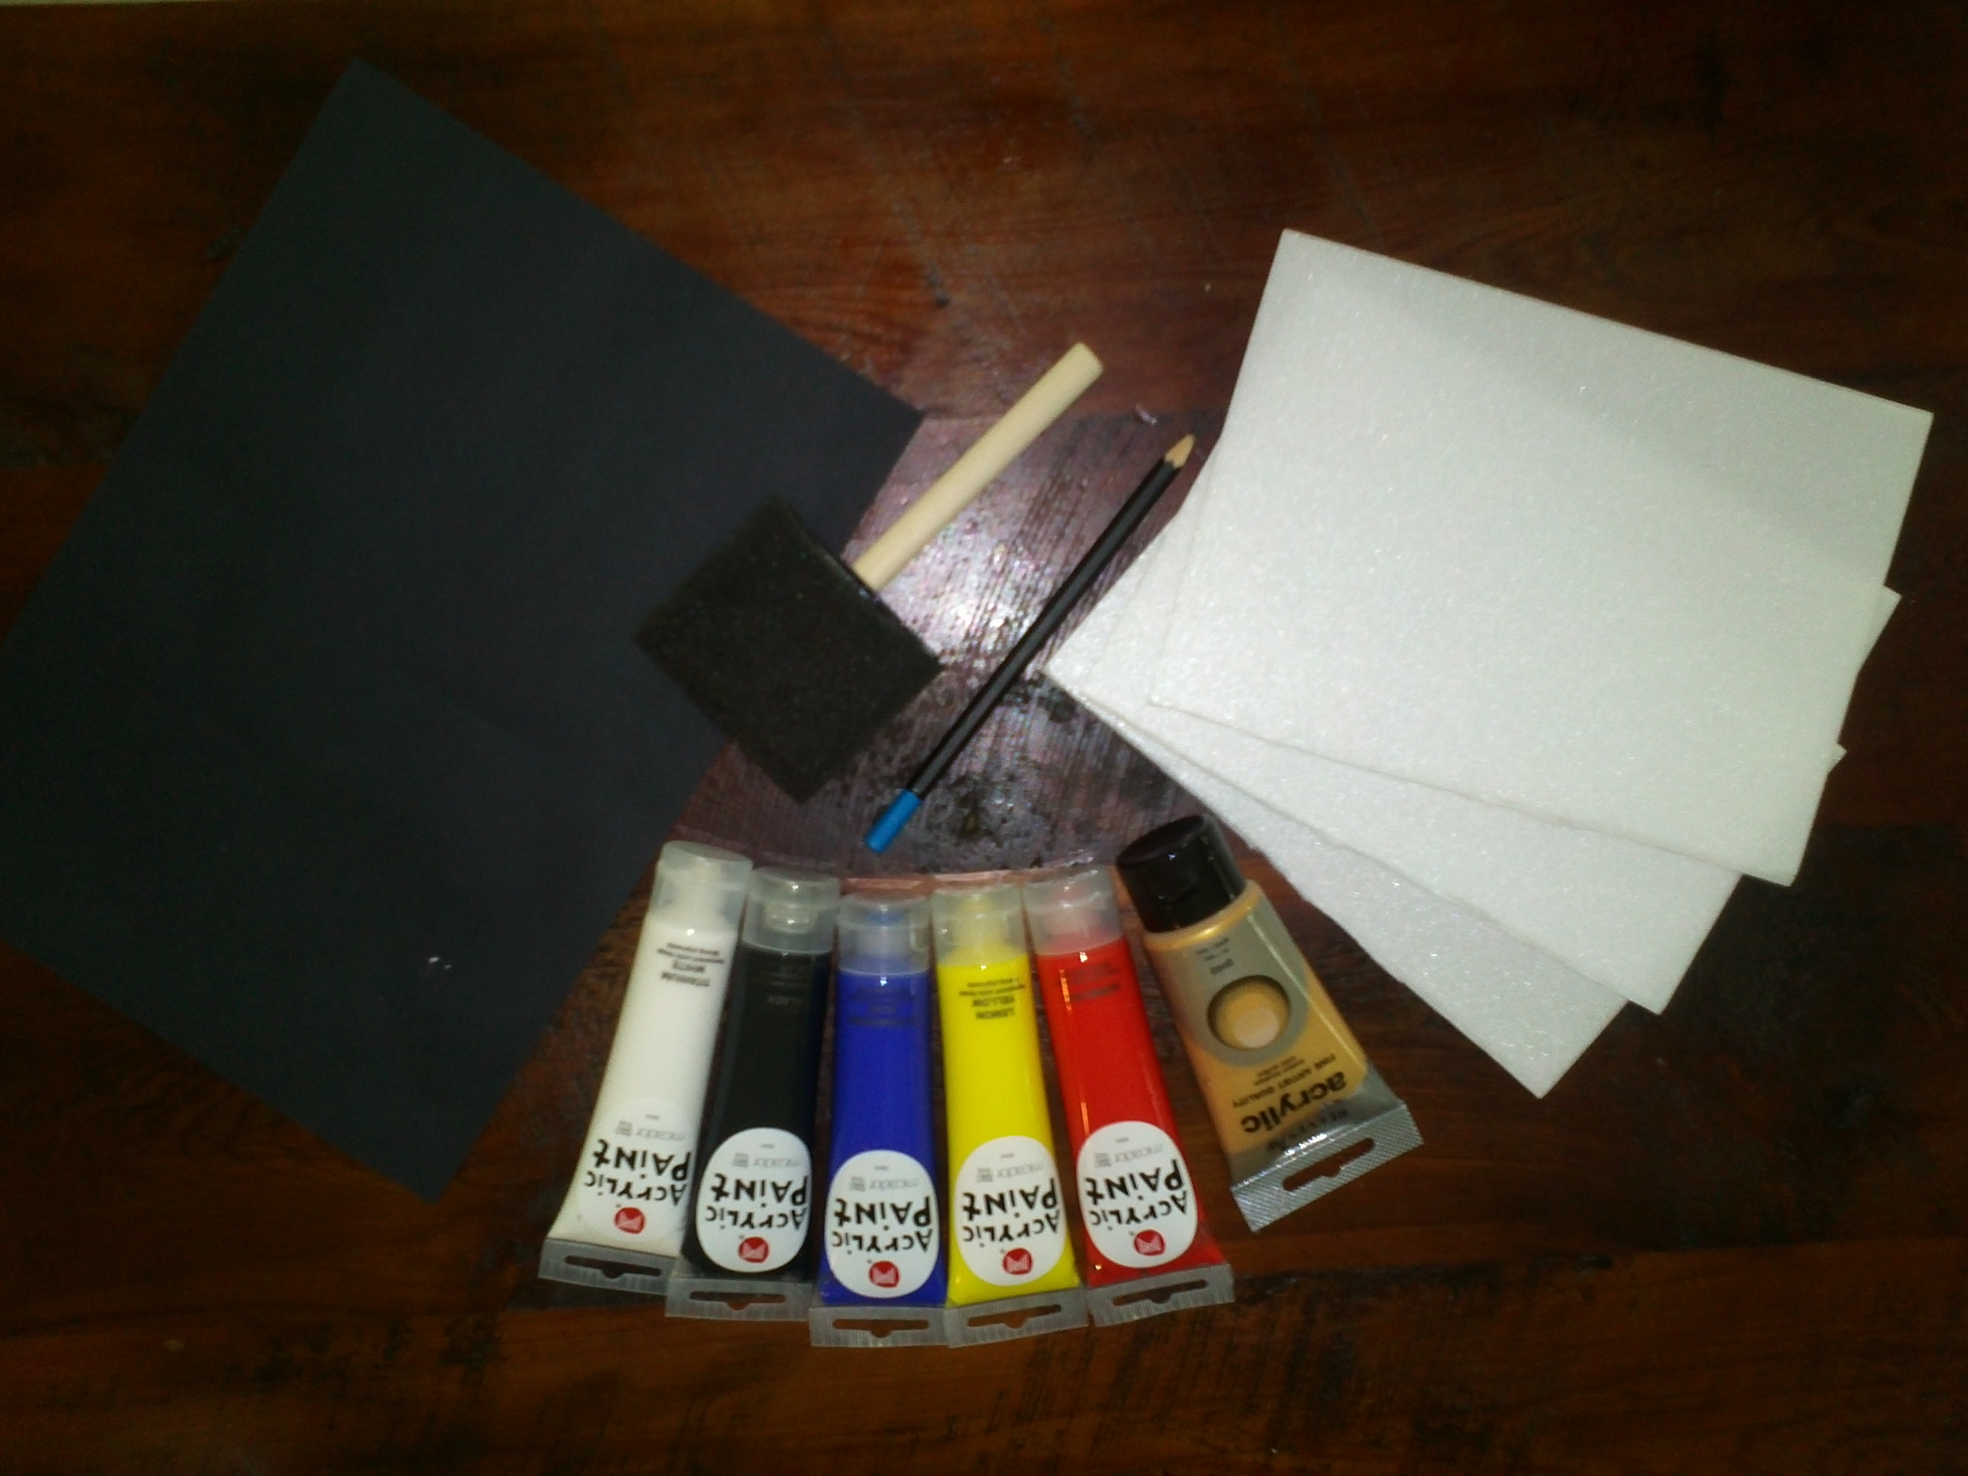

This style of art was influenced by Pablo Picasso.

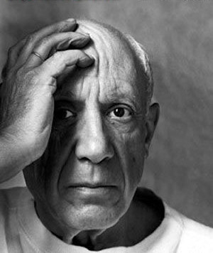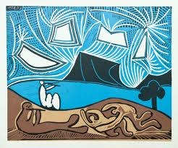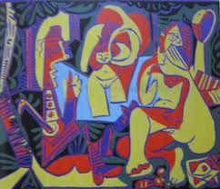

*Print Art by Picasso*

Picasso's linocuts were made by gouging out a sheet of linoleum which had been fused onto a harder block of wood.  (Linoleum, softer and lighter than wood, allowed Picasso to work more quickly than would have been possible by working from woodblocks alone.)  Using gouges, he would cut out the areas of his intended image that were to be absent of color (and therefore appear the color of the paper when printed).  The relief areas that remain would be inked, usually with a brayer.  Paper would be put on the inked linoleum block and pressure applied, after which the inked image is transferred to the paper.  If there were to be multiple colors, Picasso would create a separate linoleum block, each corresponding to a different color, each printed in succession.  This is how he worked since his first linocuts were created in 1958.

Pablo Picasso

**Born:** 25 October 1881

**Died:** 8 April 1973 (Aged 91)

**Nationality:** Spanish

**Field:** Painting, Drawing, Sculpture,

Printmaking, ceramics

**Movement:** Cubism

You will need:

* Printmaking Foam
* Acrylic Paint (limit your colour pallet)
* Paint roller/paint brush/art sponge
* Paper
* Picture or image to trace
* Brayer (ink roller

How to do it:

**Step 1:**

First choose a picture you wish to trace and place it on top of the printmaking foam.

**Step2:**

Using your pencil trace around your picture making an indentation on your printing foam of the chosen image.

**Step3:**

Cover the printing foam tile in paint.

**Step4:**

Place paper over the tile and press with your hand or brayer.

**Step 5:**

Gently peel off the paper from the tile to reveal your printed image.



You will need:

* Printmaking foam
* Acrylic Paint (variety of colours)
* Paint roller/brush or art sponge
* Paper
* Picture or image to trace
* Brayer (ink roller)

How to do it: