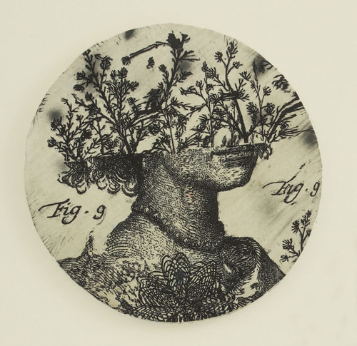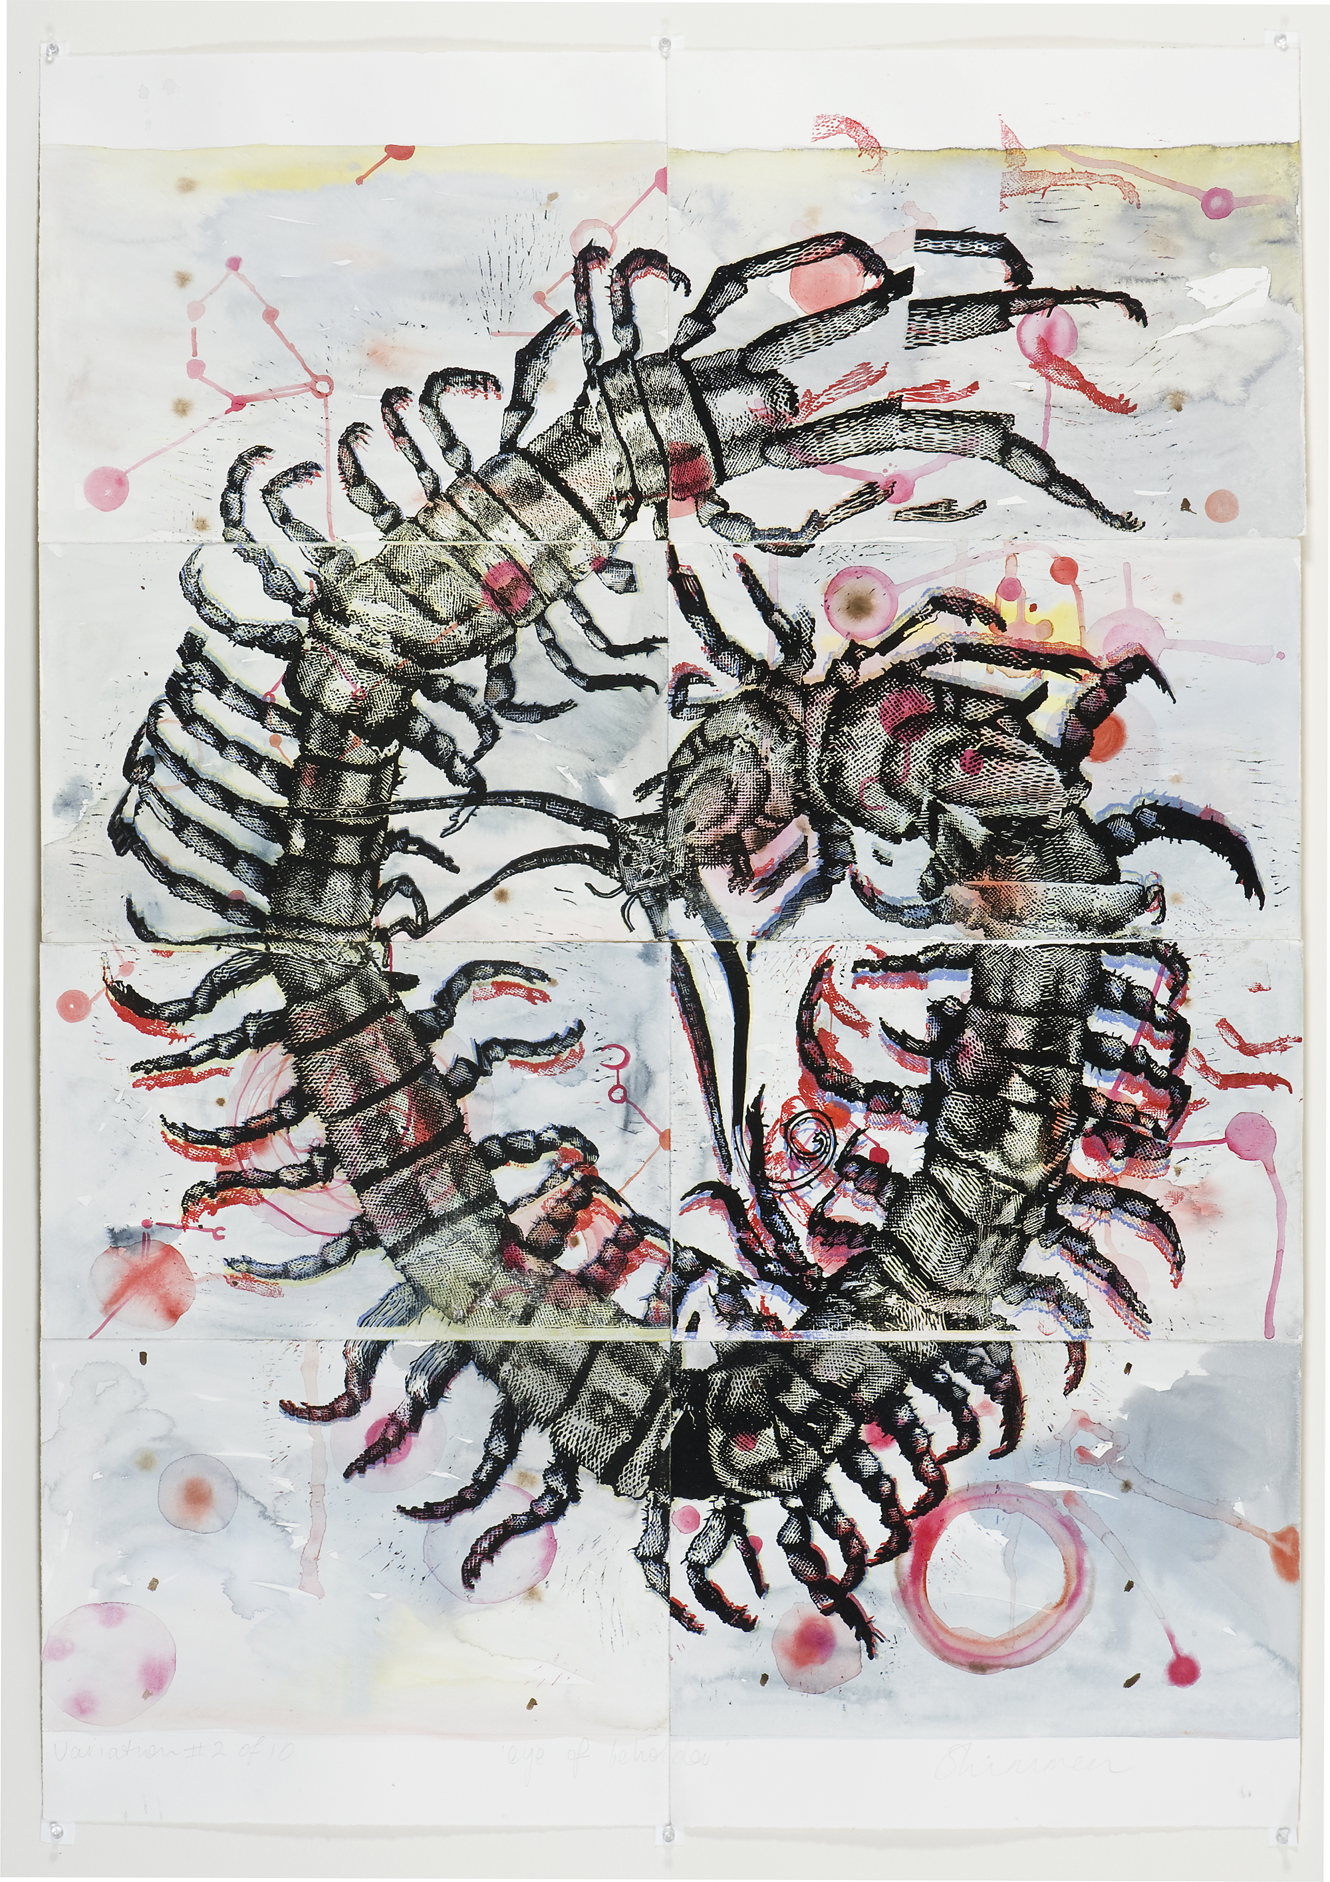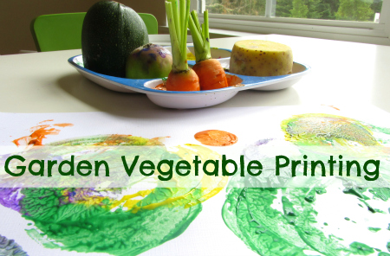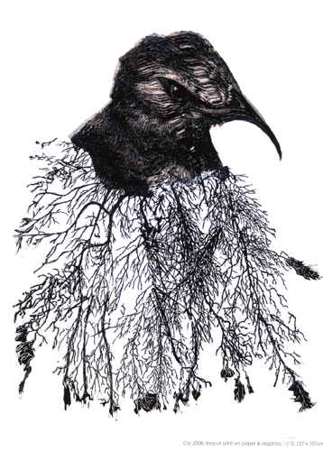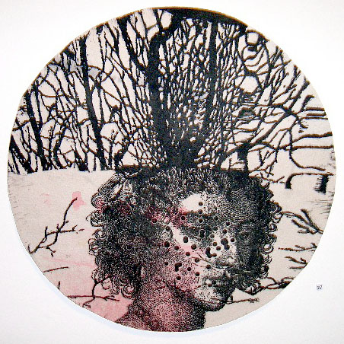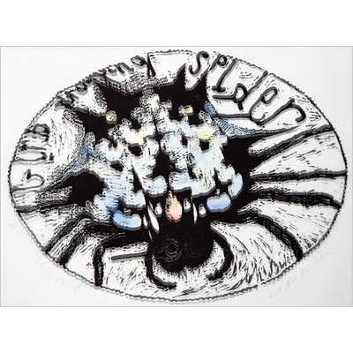

You will need:

* Cauliflower
* Broccoli
* Carrot
* Potato
* Oranges
* Peaches
* Corn on the cob
* Citrus skin
* Strawberries
* Lettuce
* Celery
* Acrylic paint (Selection of four)
* Paint Roller/ Paint brush

How to do it:

Step 1

Dip the vegetables in paint ensuring that paint is evenly covered with paint.

Step 2

Press the painted vegetable on the chosen paper leaving the vegetable print on the paper, mirroring the chosen vegetable, using as many vegetables as you like, creating as many patterns as you wish.

Heather Shimmen

Born: 8 Novemeber 1957, Melbourne

Field: Painting, Printmaking, etching

Investigate the expert…

How it Works!

Guided Instructions

Teacher preparation: Vegetables to be cut and prepared by Learning Manager.

Print art final Pieces can be used in various ways

* Book covers
* Placemats
* Whole class Mural