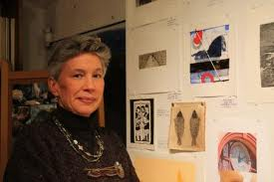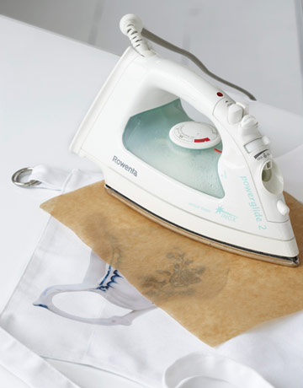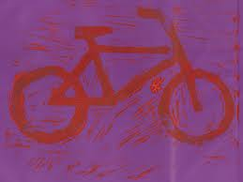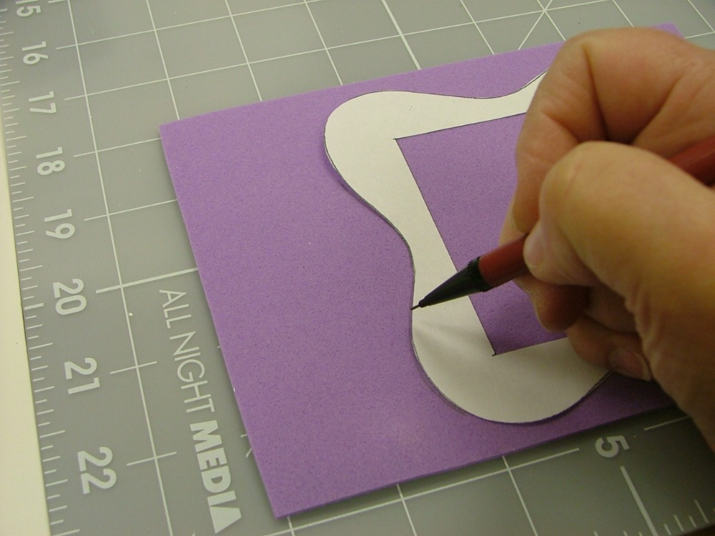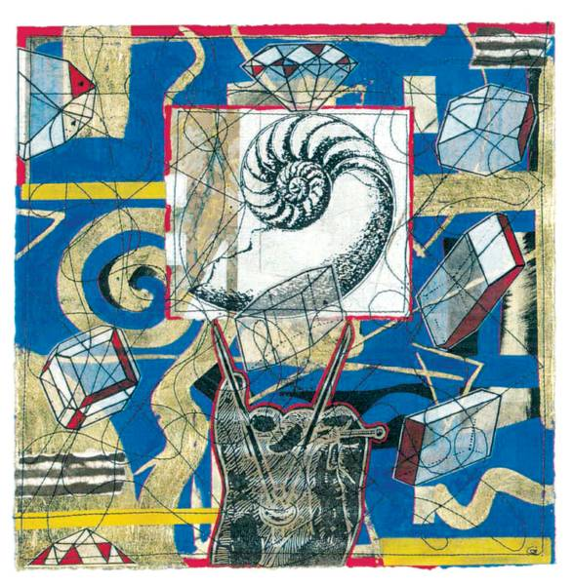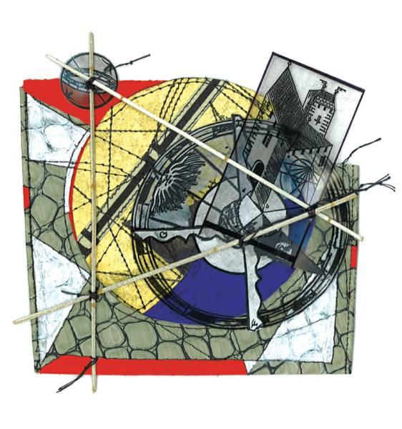

You will need:

* Fabric Paint
* T-Shirt (plane)
* Printmaking foam
* Scissors/craft knife
* Chopping Board to carve out foam if using craft knife
* Paint roller
* Images to trace

How to do it:

Step 1:

Using your chosen image trace around the image creating an indentation in the print foam.

Step 2:

Cut out your image using scissors or your craft knife with you print foam placed on top of the chopping board to protect the under surface.

Step 3:

Paint your foam image using the roller covering the entire cutout.

Step 4:

Press the cutout onto your plane shirt, carefully remove foam cutout and wait for your teacher to iron your printed image for drying

This style of art was influenced by Kim Laurel

Personal work includes: painting, printmaking, collage and mixed media works

Artist's statement: My work is symbolic commentary on sociological and environmental issues in a complex and alienating society. The themes are inadequacies in society posed as allegory.

Primal experiences, nature and personal identity

for example, so basic to our understanding of existence, are symbolized in this allegorical world. Contemporary cultural icons and words are used

to enhance or countermand the associations of the figurative images and symbols, emphasizing the dichotomy between physical self survival and spiritual isolation.

Utilizing printmaking and collage as an extension

of drawing and painting, I have found that in the realm of two dimensional expression that mixed media collage is the most authentic and subjective tool to express my voice.

<http://www.kimlaurel.com>

Investigate the expert…

How it Works!

Guided Instructions Kim Laurel Mixed Media Prints